I have rich experience for around 9 years in many different areas of software engineering.

I like to build amazing and awesome websites with my creative diverse knowledge.

I am really good at HTML, CSS, Frontend development with React, Backend development with Node, Website Design, and more using modern JavaScript, Python, PHP, Express, Django, Laravel CodeIgniter.

Over last 2 years, I have mainly focused on Blockchain technologies - developing Frontend with Web3/ether.js/Solidity, Token and Coin development.

### **Experience**

**Blockchain developer / HEMPCHAIN US**.

*From April 2020 to July 2021*

* Have developed Ethereum Smart Energy contract and react Frontend with react, web3, ether.js
* Introduce the embedded signature wallet on existing system
* Developed the web3/ether.js/polkadot on front-end and get involved on Front-end
* Developed ERC721, ERC20, ERC1155 smart contracts with solidity

**Full Stack & Web Developer / CLERK US**

*From February 2019 to August 2020*

* Creating new features, functionality and capabilities on the eCommerce sites using Django.
* Ajax, SAAS, and JSON
* Recommending solutions for a streamlined, user-friendly interface with the design team.
* Performing bug fixes and code reviews. Technical debt reduced by 32% within first month.
* Designing and implementing HTML email templates and newsletters for marketing campaigns.
* Ensuring proper documentation and reports in all stages of product life cycles

### Highlights

* Results-oriented
* Good chatting
* Effective work time
* Organizational capacity
* Operability and commitment
* Ability to motivate colleague and maintain good relations
* Resistance to stress
* Good manners

### Education

MSc. in Software Engineering : Zaporizhia National Technical University

* Software principles and practices
* Software testing and maintenance
* Cloud computing
* Service oriented development

### Hobbies

* **Fishing and Mountain climbing** - a great way to unwind, unwind and keep your mind sharp.

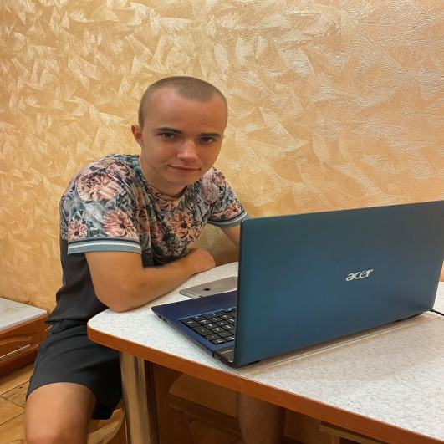

Dimitrije Kostick

Front-End ||Full-Stack & Blockchain Developer

*Perfection is not gained by anyone, but I can make everything perfect!*